Submitted By
Student Name | Astitva Sharma
Roll No | 24/SCA/BCA(Al&ML)/011
Program | BCA(AI&ML)
Subject | Python Programming
Semester | 3
Section/Group | C
Department | School of Computer Applications
Session / Batch | 2024-27
Submitted To
Faculty Name | Dr.Sakshi Gupta
Manav Rachna International Institute of Research and Studies

School of Computer Applications

Q1) Write a Python program to calculate number of days between two dates.

from datetime import date

y1, m1, d1 = map(int, input("Enter first date (YYYY MM DD): ").split())
y2, m2, d2 = map(int, input("Enter second date (YYYY MM DD): ").split())

date1 = date(y1, m1, d1)
date2 = date(y2, m2, d2)

delta = abs(date2 - date1)
print(f"Number of days between: {delta.days} days")
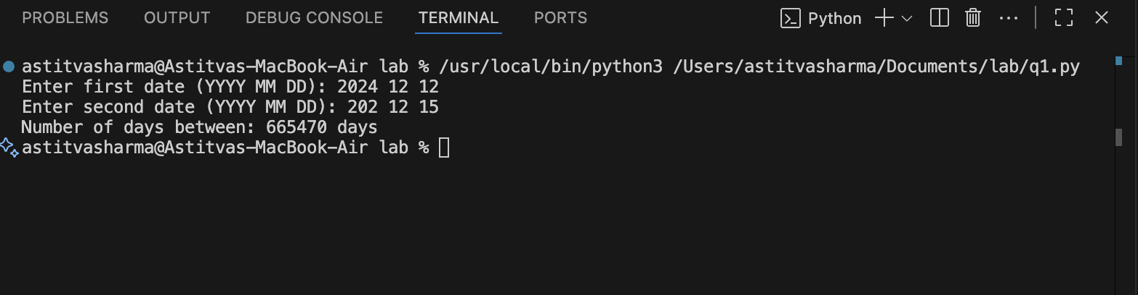

Q2) Write a Python program that accepts an integer (n) and computes the value of n+nn+nnn.

n = int(input("Enter a number: "))

result = n + int(str(n)*2) + int(str(n)*3)
print("Result:", result)
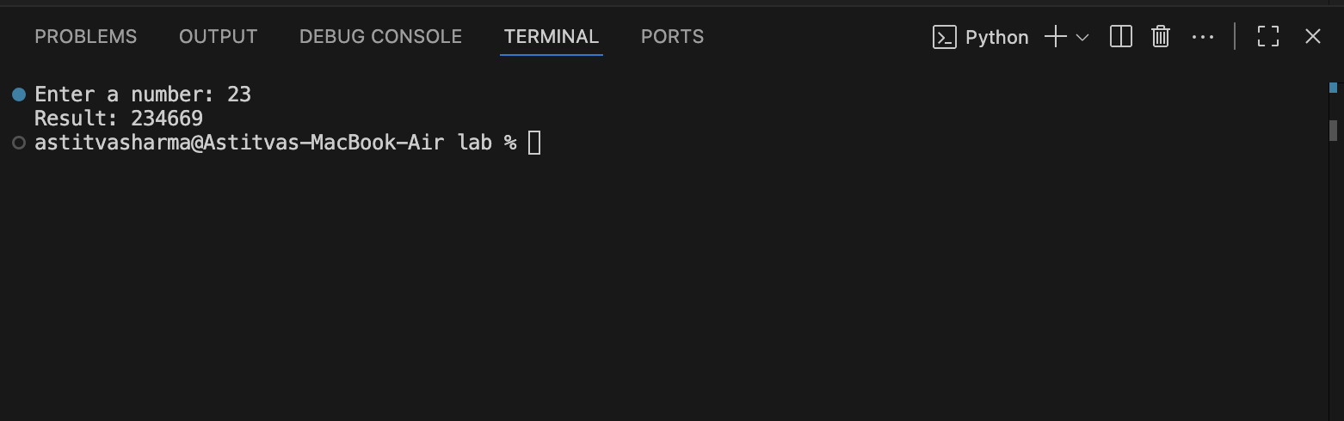

Q3) Ask the user for a number. Depending on whether the number is even or odd, print out an appropriate message to the user. Hint: how does an even / odd number react differently when divided by 2?

num = int(input("Enter a number: "))

if num % 2 == 0:
print(f"The number {num} is EVEN. That means it is divisible by 2 without any remainder.")
else:
print(f"The number {num} is ODD. That means when divided by 2, it leaves a remainder of 1.")

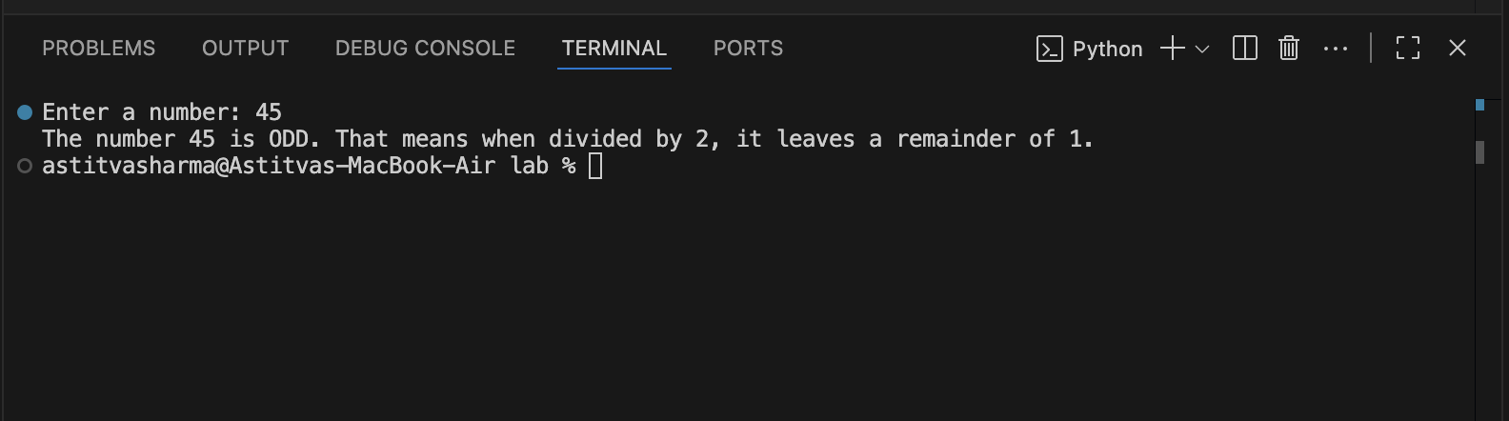

Q4) Write a Python program which accepts a sequence of comma-separated numbers from user and generate a list
and a tuple with those numbers.

numbers = input("Enter numbers separated by commas: ")
num_list = numbers.split(",")
num_tuple = tuple(num_list)
print("List:", num_list)
print("Tuple:", num_tuple)
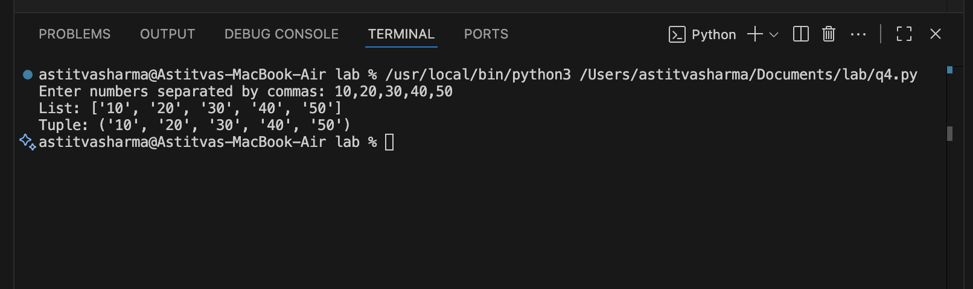

Q5) Write a Python program to calculate the sum of three given numbers, if the values are equal then return thrice of their sum.

a = int(input("Enter first number: "))
b = int(input("Enter second number: "))
c = int(input("Enter third number: "))

if a == b == c:
print("Result:", 3 * (a + b + c))
else:
print("Result:", a + b + c)

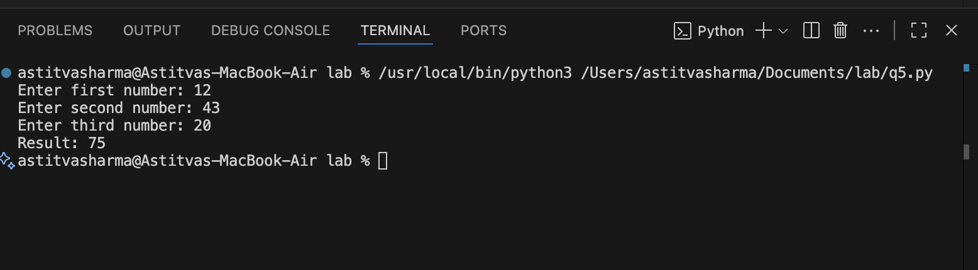

Q6) Write a Python program to test whether a passed letter is a vowel or not.

ch = input("Enter a letter: ")

if ch.lower() in "aeiou":
print(ch, "is a vowel")
else:
print(ch, "is not a vowel")
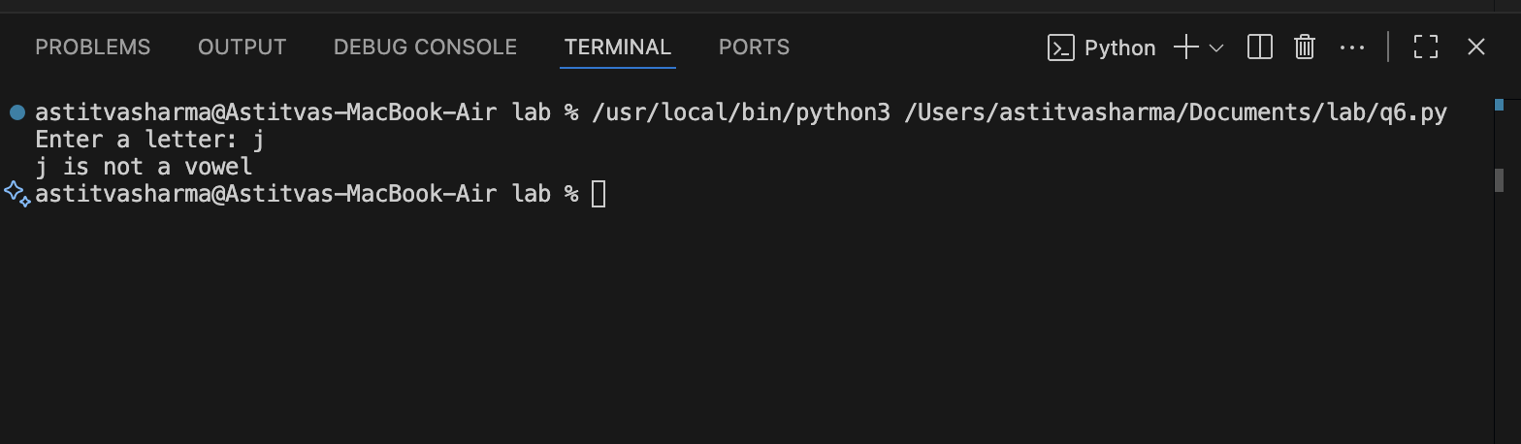

Q7)Take a list, say for example this one:
a = [1, 1, 2, 3, 5, 8, 13, 21, 34, 55, 89]
and write a program that prints out all the elements of the list that are less than 5.
Extras:

- Instead of printing the elements one by one, make a new list that has all the elements less than 5 from this list in it and print out this new list.
- Write this in one line of Python.
Ask the user for a number and return a list that contains only elements from the original list a that are smaller than that number given by the user.

a = [1, 1, 2, 3, 5, 8, 13, 21, 34, 55, 89]
for i in a:
if i < 5:
print(i)
new_list = [x for x in a if x < 5]
print("New List:", new_list)
print([x for x in a if x < 5])
num = int(input("Enter a number: "))
print([x for x in a if x < num])
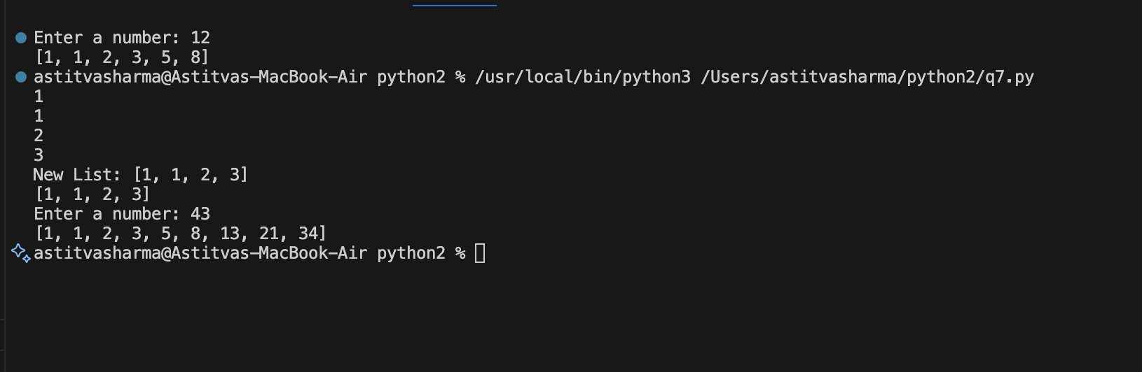

Q8)Create a program that asks the user for a number and then prints out a list of all the divisors of that number. (If you don’t know what a divisor is, it is a number that divides
evenly into another number. For example, 13 is a divisor of 26 because 26 / 13 has no remainder.)

n = int(input("Enter a number: "))
divisors = [i for i in range(1, n + 1) if n % i == 0]
print("Divisors of", n, "are:", divisors)

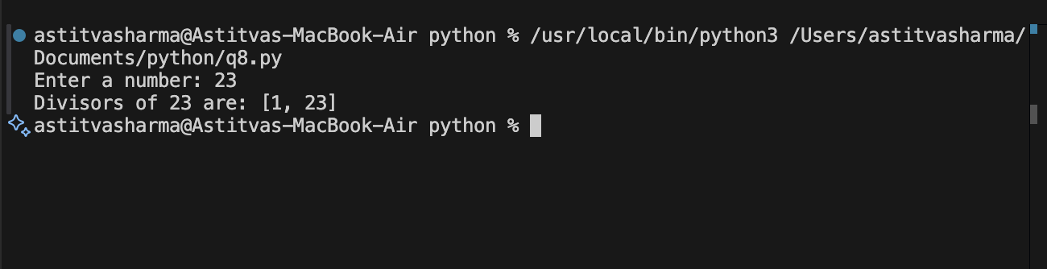

Q9)Take two lists, say for example these two:
a = [1, 1, 2, 3, 5, 8, 13, 21, 34, 55, 89]
b = [1, 2, 3, 4, 5, 6, 7, 8, 9, 10, 11, 12, 13]
and write a program that returns a list that contains only the elements that are common between the lists (without duplicates). Make sure your program works on two lists of
different sizes.

a = [1, 1, 2, 3, 5, 8, 13, 21, 34, 55, 89]
b = [1, 2, 3, 4, 5, 6, 7, 8, 9, 10, 11, 12, 13]
common = list(set(a) & set(b))
print("Common elements:", common)

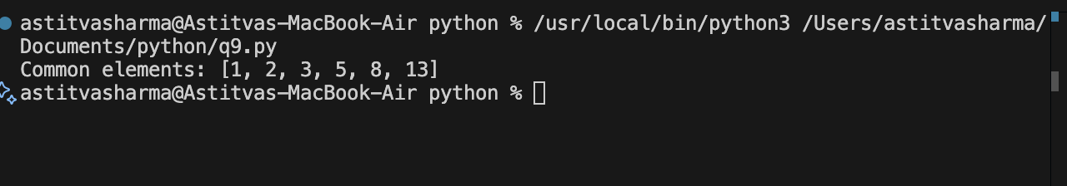

Q10) Ask the user for a string and print out whether this string is a palindrome or not. (A palindrome is a string that reads the same forwards and backwards.)

s = input("Enter a string: ")
if s == s[::-1]:
print("Palindrome")
else:
print("Not a palindrome")

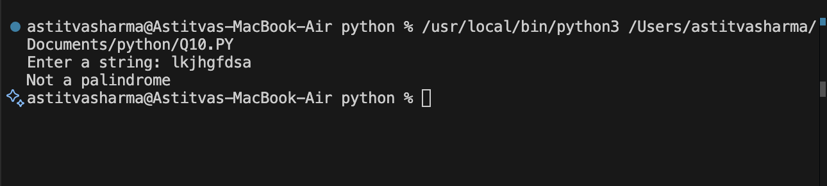

Q11)Let’s say I give you a list saved in a variable: a = [1, 4, 9, 16, 25, 36, 49, 64, 81, 100]. Write one line of Python that takes this list a and makes a new list that has only the even elements of this list in it.

a = [1, 4, 9, 16, 25, 36, 49, 64, 81, 100]
even_list = [x for x in a if x % 2 == 0]
print("Even elements list:", even_list)

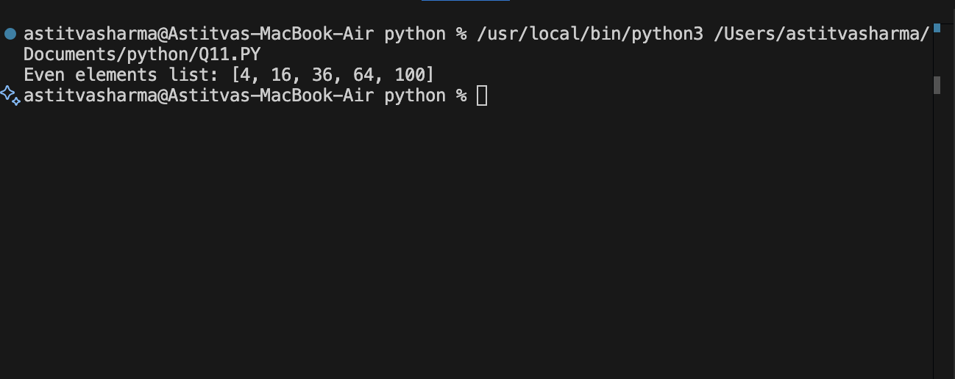

Q12)Generate a random number between 1 and 9 (including 1 and 9). Ask the user to guess the number, then tell them whether they guessed too low, too high, or exactly right. (Hint: remember to use the user input lessons from the
very first exercise)

import random

num = random.randint(1, 9)
guess = int(input("Guess a number between 1 and 9: "))

if guess < num:
print("Too low!")
elif guess > num:
print("Too high!")
else:
print("Exactly right!")

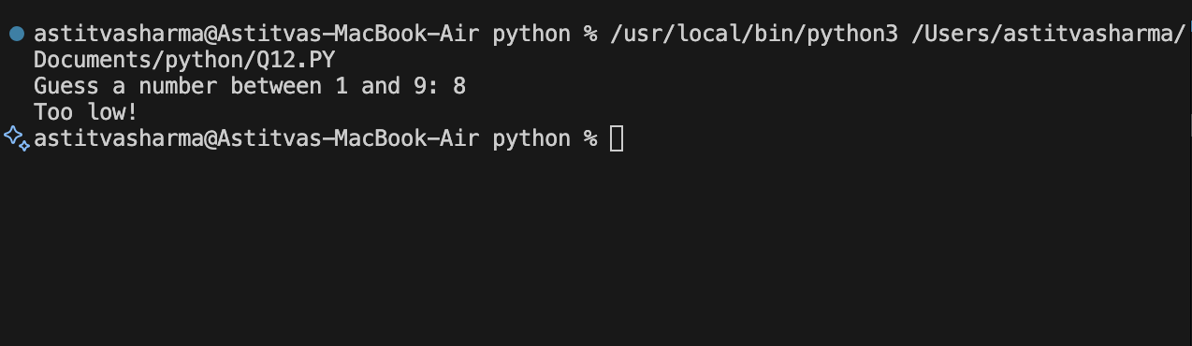
Ask the user for a number and determine whether the
Q13)Ask the user for a number and determine whether the
number is prime or not. (For those who have forgotten, a prime number is a number that has no divisors.).

n = int(input("Enter a number: "))

if n > 1:
for i in range(2, n):
if n % i == 0:
print(n, "is not a prime number")
break
else:
print(n, "is a prime number")
else:
print(n, "is not a prime number")

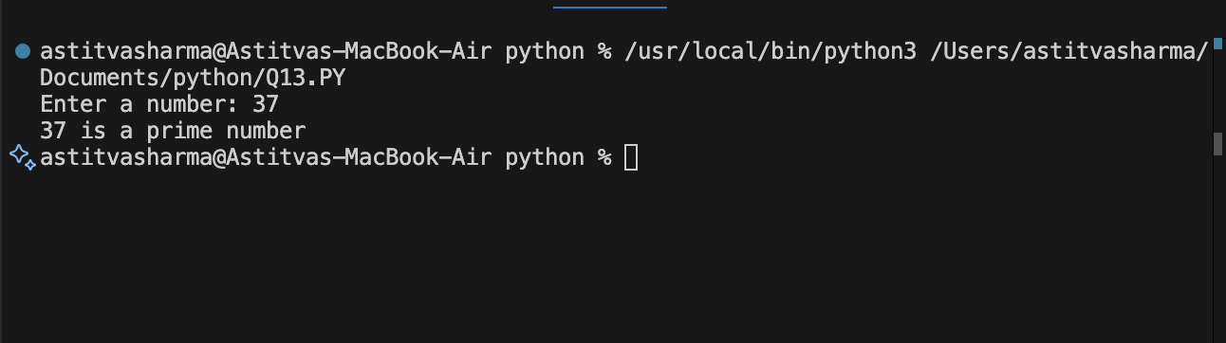
Q14)Write a program (function!) that takes a list and returns a
new list that contains all the elements of the first list minus all the duplicates.

def remove_duplicates(lst):
return list(set(lst))

a = [1, 2, 2, 3, 4, 4, 5]
print("Original:", a)
print("Without duplicates:", remove_duplicates(a))

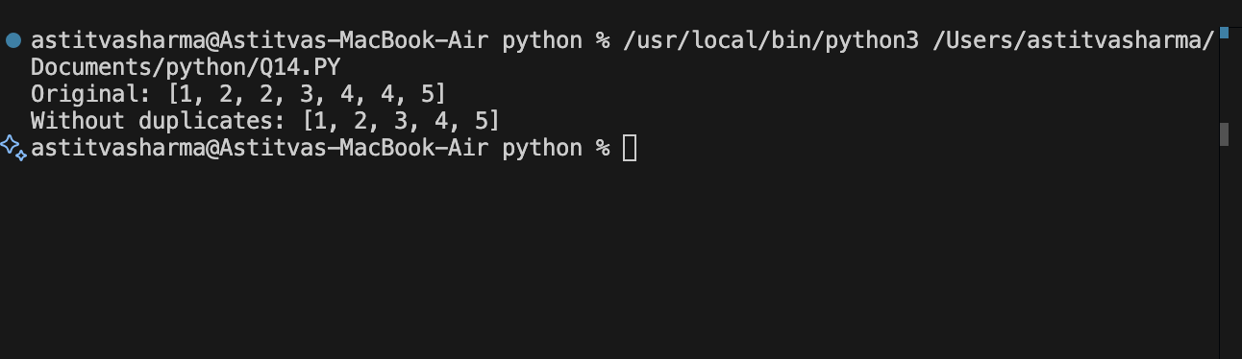

Q15)Write a function that takes an ordered list of numbers (a list where the elements are in order from smallest to largest) and another number. The function decides whether
or not the given number is inside the list and returns (then prints) an appropriate boolean.

def check_number(lst, num):
if num in lst:
print(True)
else:
print(False)

lst = [1, 3, 5, 7, 9, 11]
num = int(input("Enter number to search: "))
check_number(lst, num)

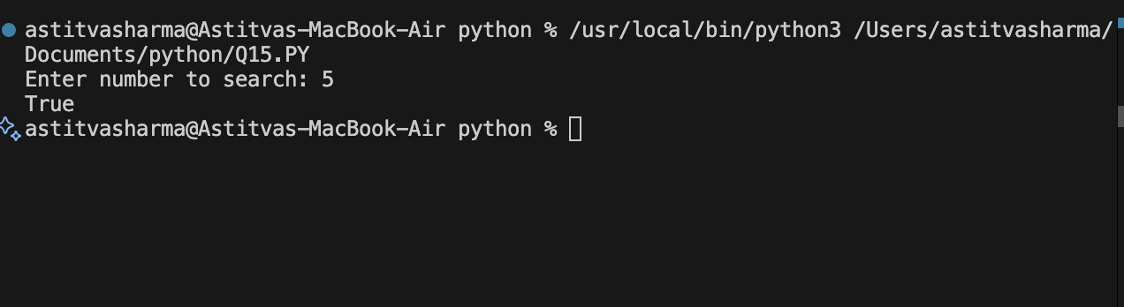
Q16)Implement a function that takes as input three variables,
and returns the largest of the three. Do this without using the Python max() function!

a = int(input("Enter first number: "))
b = int(input("Enter second number: "))
c = int(input("Enter third number: "))

if a >= b and a >= c:
largest = a
elif b >= a and b >= c:
largest = b
else:
largest = c

print("Largest number is:", largest)

